Table Creation

CREATE TABLE MANAGER

(

MANAGER_ID NUMBER (10) CONSTRAINT MANAGER_MID_PK PRIMARY KEY,

FIRST_NAME VARCHAR2 (20) ,

LAST_NAME VARCHAR2 (20) ,

BRANCH VARCHAR2 (15) ,

PHONE_NUMBER NUMBER (16) ,

EMAIL VARCHAR2 (20)

)

DESC MANAGER

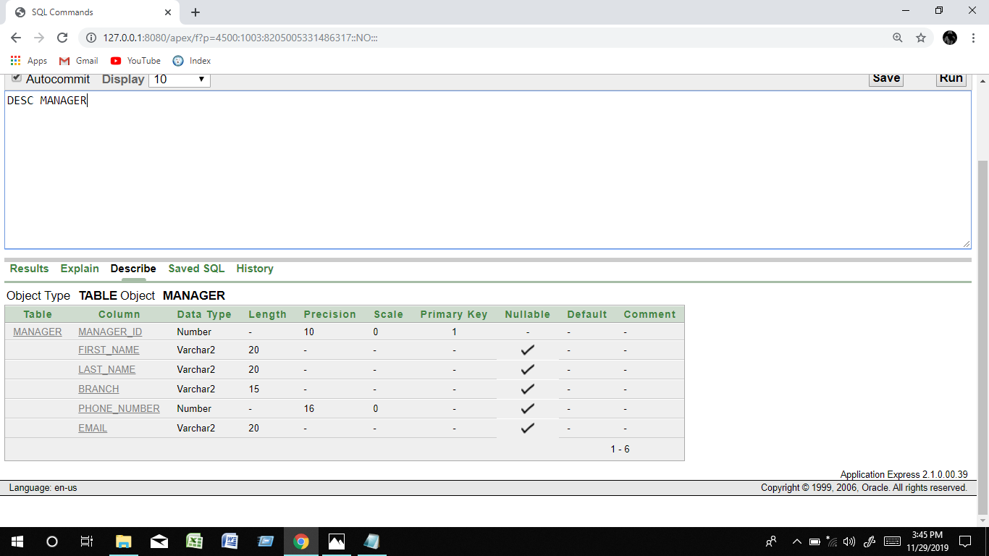

CREATE TABLE SUPERVISOR

(

SUPERVISOR_ID NUMBER (10) CONSTRAINT SUPERVISOR_SID_PK PRIMARY KEY,

fIRST_NAME VARCHAR2 (20) ,

LAST_NAME VARCHAR2 (20) ,

BRANCH VARCHAR2 (15),

PHONE_NUMBER NUMBER (16),

MANAGER_ID NUMBER(20) CONSTRAINT SUPERVISOR_SID_FK REFERENCES MANAGER(MANAGER_ID)

)

DESC SUPERVISOR

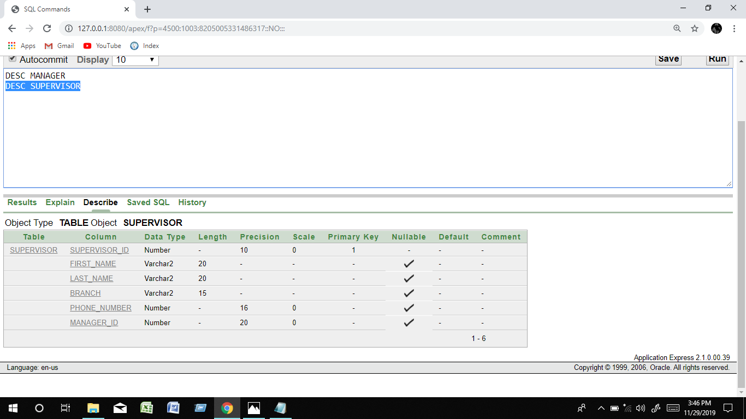

CREATE TABLE GUARD_INFO

(

GUARD_ID NUMBER (10) CONSTRAINT GUARD_GID_PK PRIMARY KEY ,

FIRST_NAME VARCHAR2 (20) ,

LAST_NAME VARCHAR2 (20) ,

DOB DATE,

ADDRESS VARCHAR2 (30),

PHONE_NUMBER NUMBER (16),

SUPERVISOR_ID NUMBER (10) CONSTRAINT GUARD_GID_FK REFERENCES SUPERVISOR(SUPERVISOR_ID)

)

DESC GUARD_INFO

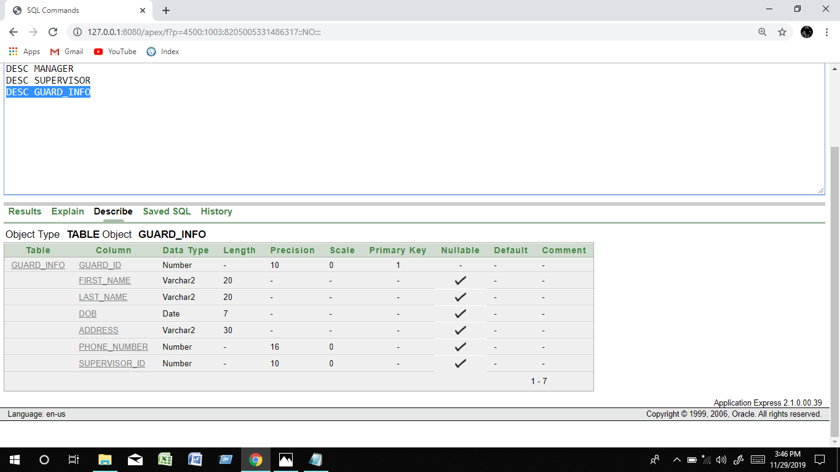

CREATE TABLE ACCOUNT

(

AN NUMBER (10) CONSTRAINT ACCOUNT_AN_PK PRIMARY KEY ,

SALARY_AMOUNT NUMBER (10,2),

COMMISSION NUMBER (6,2),

GUARD_ID NUMBER(10) CONSTRAINT ACCOUNT_AN_FK REFERENCES GUARD_INFO(GUARD_ID)

)

DESC ACCOUNT

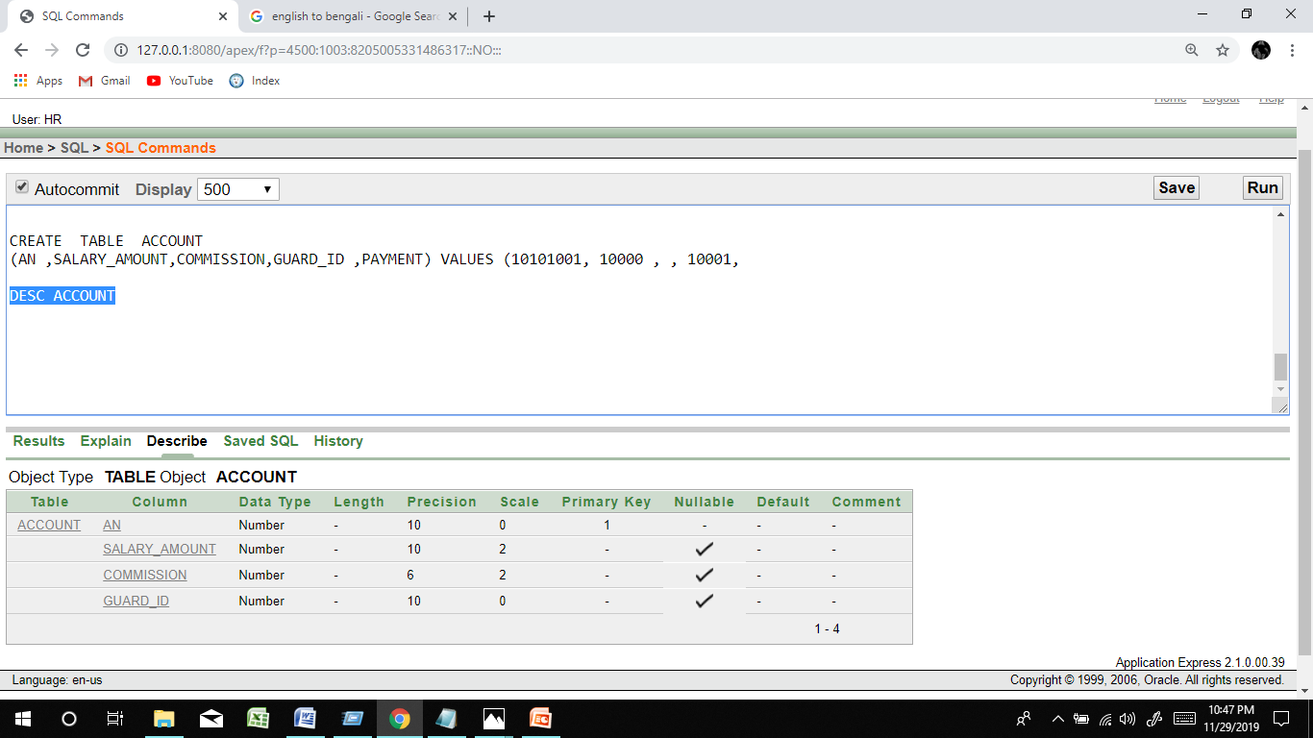

CREATE TABLE GUARD

(

GUARD_ID NUMBER(10) CONSTRAINT GUARD_GUARDID_FK REFERENCES GUARD_INFO(GUARD_ID) ,

SUPERVISOR_ID NUMBER(10) CONSTRAINT GUARD_GUAEDID_FK REFERENCES SUPERVISOR(SUPERVISOR_ID),

HIRE_DATE DATE,

SERVICE_TYPE VARCHAR2(10)

)

DESC GUARD

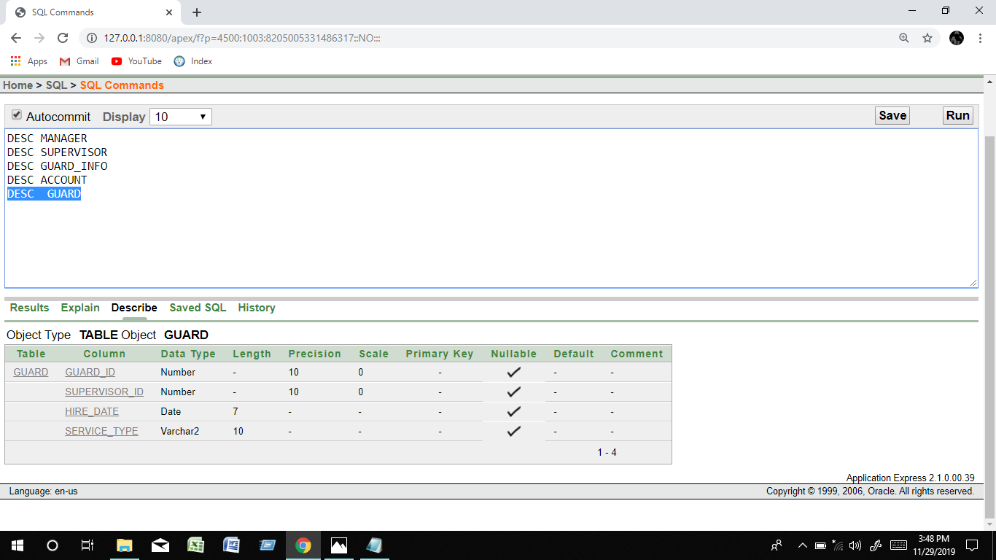

CREATE TABLE APPOINTING_INSTITUTION

(

AI_CODE_NUMBER NUMBER (10) CONSTRAINT APPIN_IN_PK PRIMARY KEY ,

NAME VARCHAR2 (10),

EMAIL VARCHAR2 (20),

ADDRESS VARCHAR2 (30),

PHONE_NUMBER NUMBER (16)

)

DESC APPOINTING_INSTITUTION

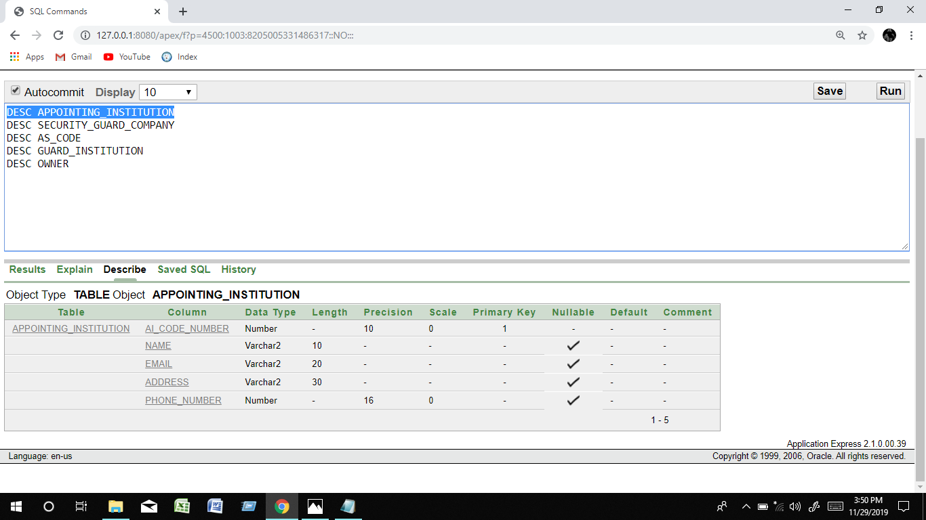

CREATE TABLE SECURITY_GUARD_COMPANY

(

SGC_CODE_NUMBER NUMBER (10) CONSTRAINT SEU_SGC_PK PRIMARY KEY ,

NAME VARCHAR2(10),

EMAIL VARCHAR2(20),

ADDRESS VARCHAR2(30),

PHONE_NUMBER NUMBER(16),

TYPE VARCHAR2 (10),

OID NUMBER(10)

)

DESC SECURITY_GUARD_COMPANY

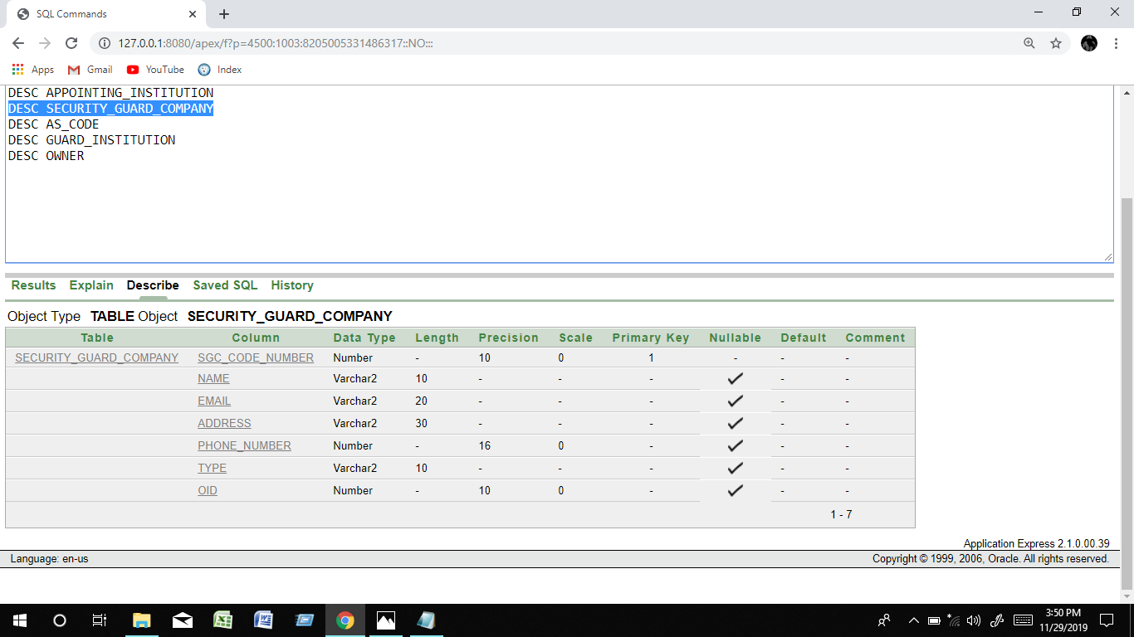

CREATE TABLE AS_CODE

(

AS_CODE_NUMBER NUMBER(10) CONSTRAINT AS_CODE_PK PRIMARY KEY ,

AI_CODE_NUMBER NUMBER (10) CONSTRAINT AS_AICODE_FK REFERENCES APPOINTING_INSTITUTION(AI_CODE_NUMBER),

SGC_CODE_NUMBER NUMBER(10 ) CONSTRAINT AS_SGCCODE_FK REFERENCES SECURITY_GUARD_COMPANY(SGC_CODE_NUMBER)

)

DESC AS_CODE

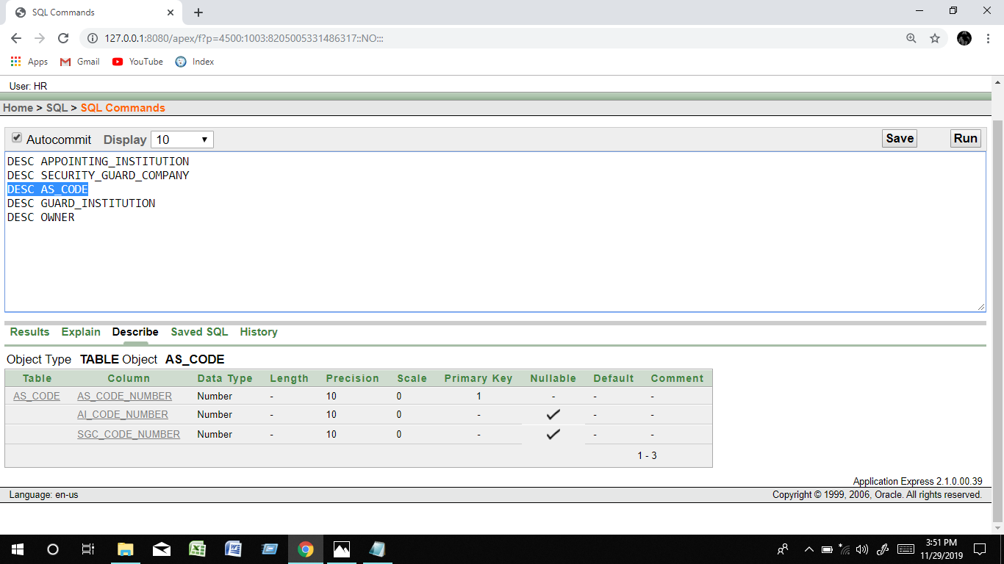

CREATE TABLE GUARD_INSTITUTION

(

GUARD_ID NUMBER(10) CONSTRAINT GUARDIN_GUARDID_FK REFERENCES GUARD_INFO(GUARD_ID),

FIRST_NAME VARCHAR2(20) ,

LAST_NAME VARCHAR2(20) ,

DOB DATE,

ADDRESS VARCHAR2(30),

PHONE_NUMBER NUMBER(16),

AI_CODE_NUMBER NUMBER(10)

)

DESC GUARD_INSTITUTION

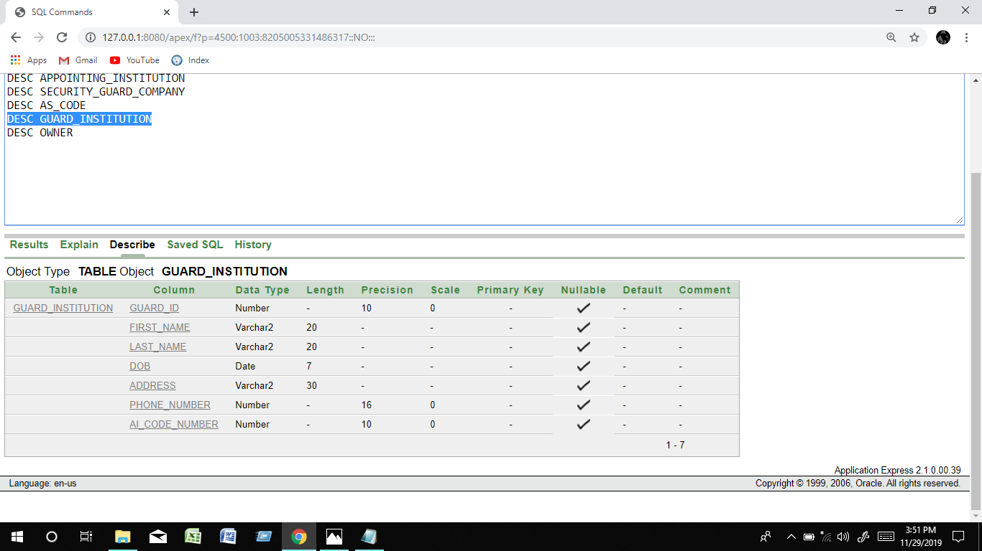

CREATE TABLE OWNER

(

OID NUMBER(10) CONSTRAINT OWNER_OID_PK PRIMARY KEY ,

FIRST_NAME VARCHAR2(20) ,

LAST_NAME VARCHAR2(20) ,

BRANCH VARCHAR2(15),

PHONE_NUMBER NUMBER(16),

EMAIL VARCHAR2 (20),

SCG_CODE_NUMBER NUMBER(10) CONSTRAINT OWNER_OID_FK REFERENCES SECURITY_GUARD_COMPANY(SGC_CODE_NUMBER)

)

DESC OWNER

